**Day 9**

**Exploitation Analyst**

**Hacking the SSL Network protocol:**

**Heartbleed Attack:**

**What is Heartbleed Attack? CVE-2014-0160**

Heartbleed is a critical vulnerability in the OpenSSL cryptographic library, disclosed in 2014. It affects the TLS/SSL heartbeat extension, allowing attackers to read sensitive data from a server’s memory—without authentication.

**What is Heartbeat?**

A heartbeat request is part of the TLS Heartbeat Extension (RFC 6520)—used to keep an SSL/TLS connection alive without renegotiating it.

**How It Works (Normally):**

1. Client sends a small packet:  
   ➤ "Here is some data (X bytes). Please send it back to prove you’re still there."
2. Server reads the length field X, and replies with exactly the same data.
3. It helps to keep idle TLS connections active (e.g., for performance).

**What Went Wrong (Heartbleed Bug):**

In vulnerable OpenSSL versions:

* The server trusted the X value provided by the client.
* But the client could lie and say:

“Here's 1 byte of data, but treat it as 64,000 bytes.”

* The server would then respond with:

➤ 1 byte + 63,999 bytes of memory leak from its RAM.

**Heartbleed Exploit - Discovery & Exploitation**

Steps:

Start the Bee box virtual machine: as it is vulnerable to the Heartbleed attack.

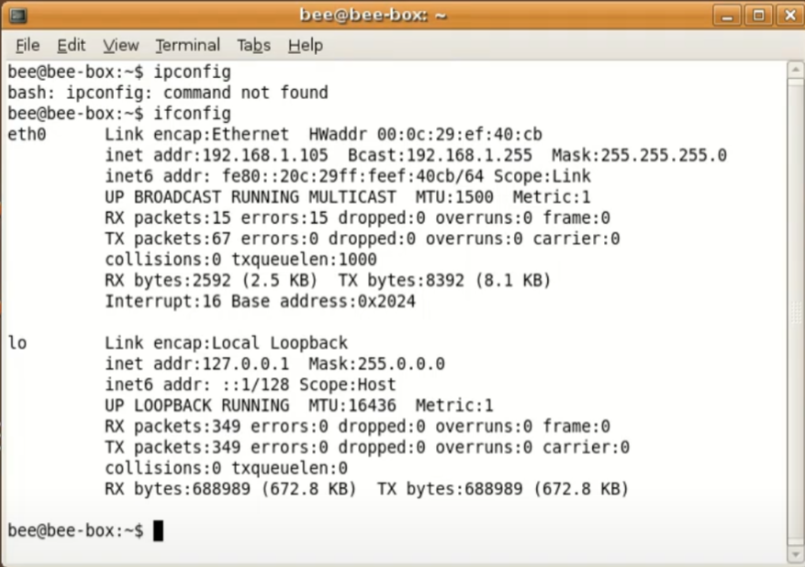

Now, open the web browser in kali and enter the IP of the bee box: following screen will appear

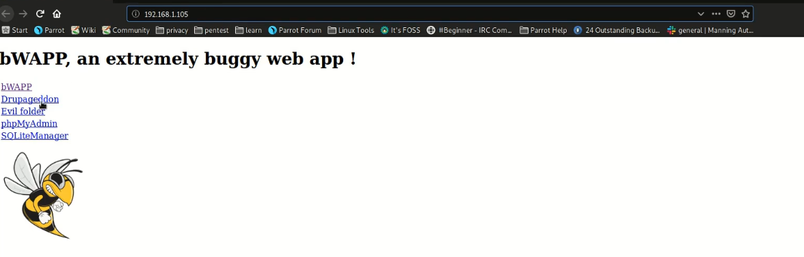

Click on the ‘bWAPP’ link and on the right corner select the vulnerability:

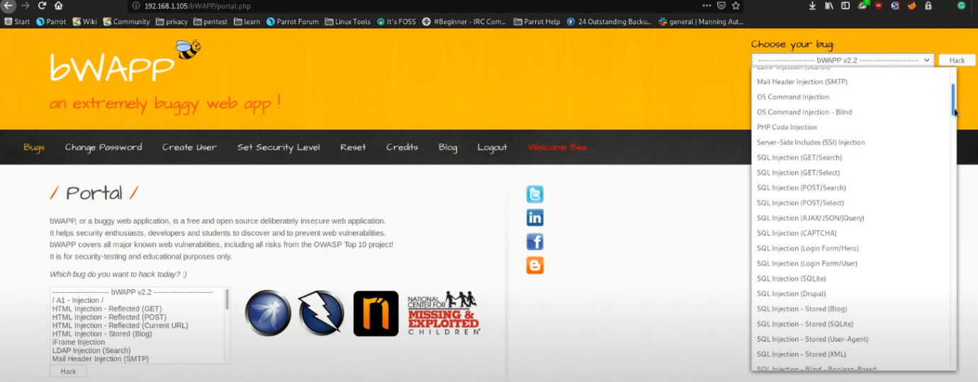

Then click on the ‘hack’ button: it will load the IP with this Heartbleed vulnerability.

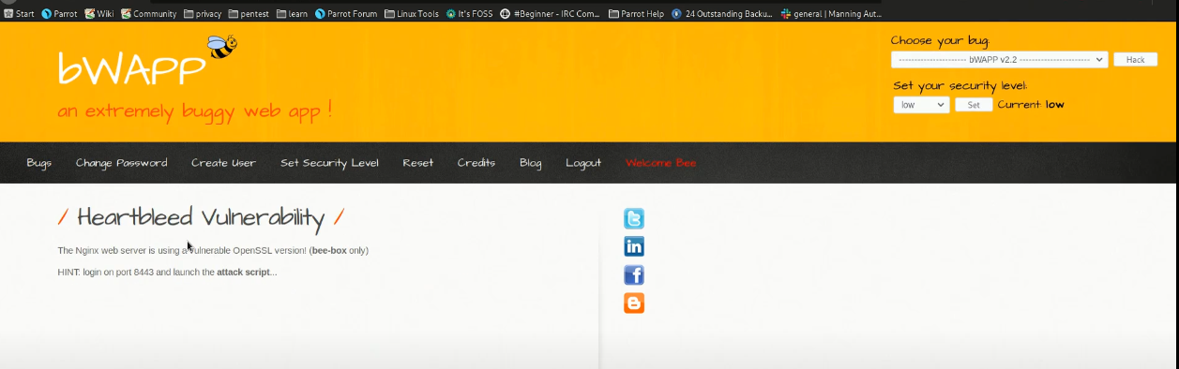

You can cross verify this using he namp:

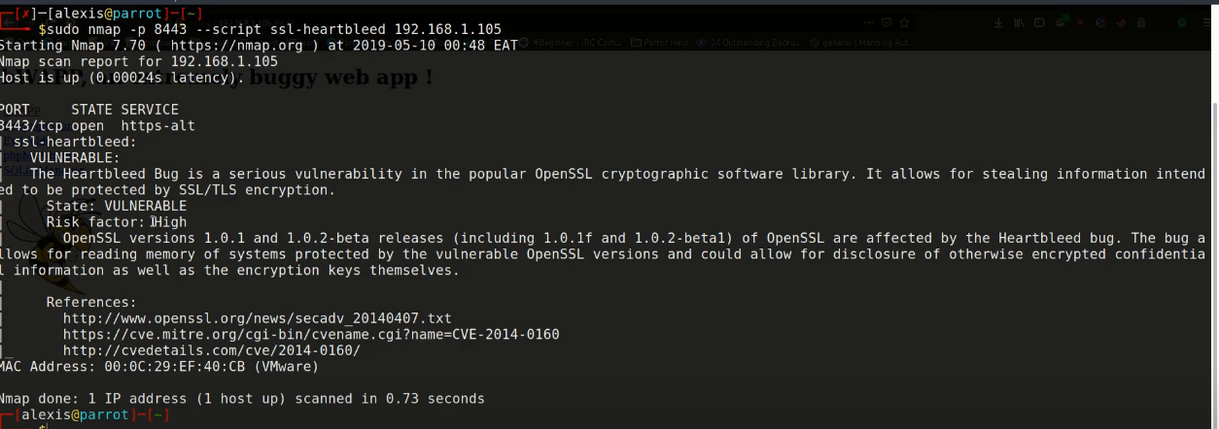

Now, start the Msfconosle and search for this module:

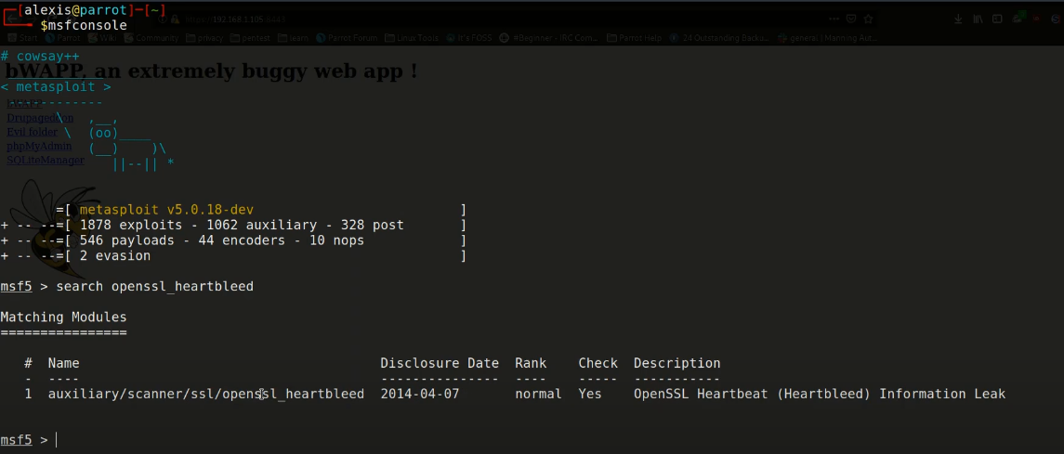

Now, just use that module and set the options we need as shown below:

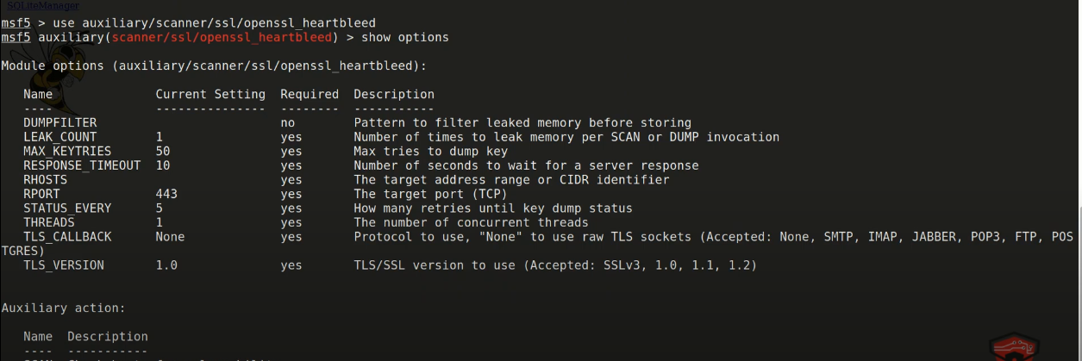

Now, set the RHOSTS and RPORT options, and then try the below commands:

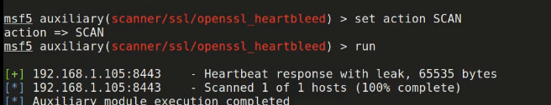

Now, we will logout of the webapp running the bee box and then again log in.

Then we will do this to get the credentials we entered while bee box was logged in:

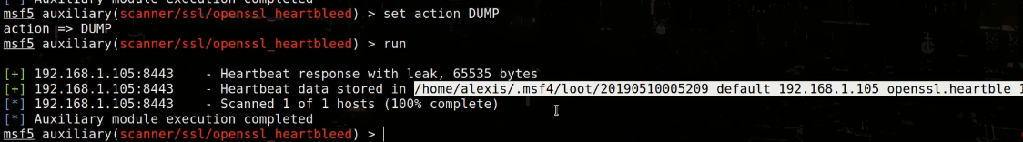

Open the saved file: clearly the id and password is available.

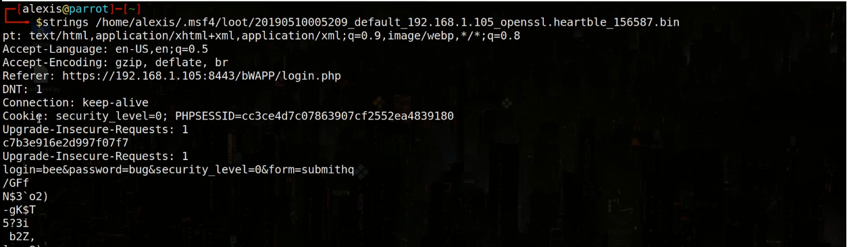

**How to protect against the Heartbleed attack?**

* Update OpenSSL  
  Ensure you're using OpenSSL 1.0.1g or later (or any version ≥1.0.2).

openssl version

* Recompile Software  
  If you compiled OpenSSL manually, recompile dependent apps (e.g., nginx, Apache) after upgrading OpenSSL.
* Reissue SSL Certificates  
  Since Heartbleed could leak private keys, revoke and reissue your TLS/SSL certificates if you were previously vulnerable.
* Rotate Private Keys  
  Generate new private keys to prevent reuse of potentially compromised credentials.
* Use IDS/IPS  
  Deploy intrusion detection/prevention systems (e.g., Snort, Suricata) with Heartbleed signatures.
* Scan Regularly  
  Use tools like nmap, sslscan, or testssl.sh:

nmap -p 443 --script ssl-heartbleed <target>

* Limit Public Exposure

Avoid exposing test/dev servers or embedded devices to the public Internet if they use SSL/TLS.

* Disable Heartbeat (if patching is not possible)

Compile OpenSSL with the -DOPENSSL_NO_HEARTBEATS flag.

* Monitor Logs

Watch for suspicious requests or memory leaks in TLS sessions.

--The End--